Data Management.

There is a need for an application for management of data into database. The user has a .xlxs file format which contains data of class students .

**Features**

* **Upload a xls file in input box**
* Check for correct file format if error in format reject

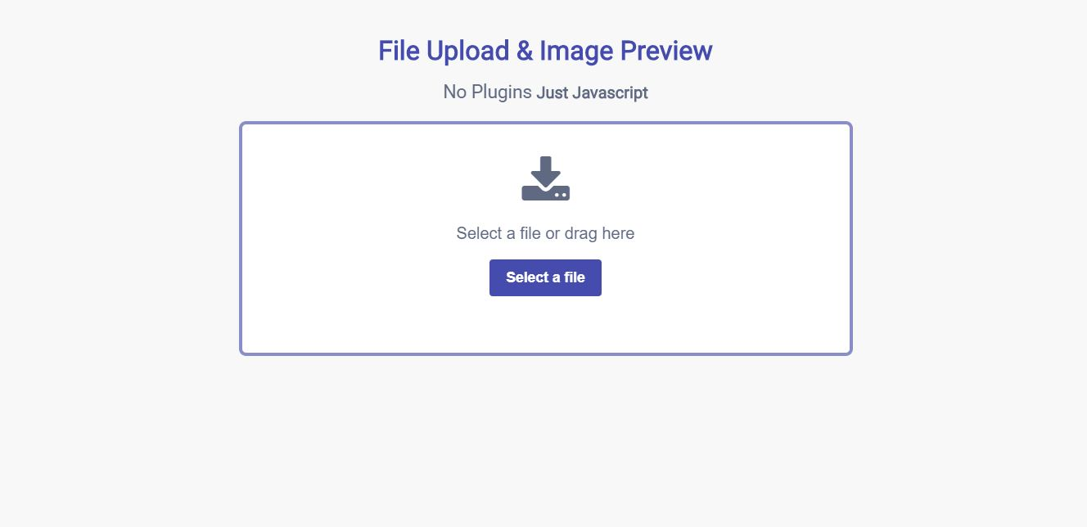

* **Validation of uploaded data**
* Check for error in file data
* Null error
* Undefined
* White space
* Check for miss-match data in file data
* Add list the number of errors and also list the number of correct data in a report above in table format

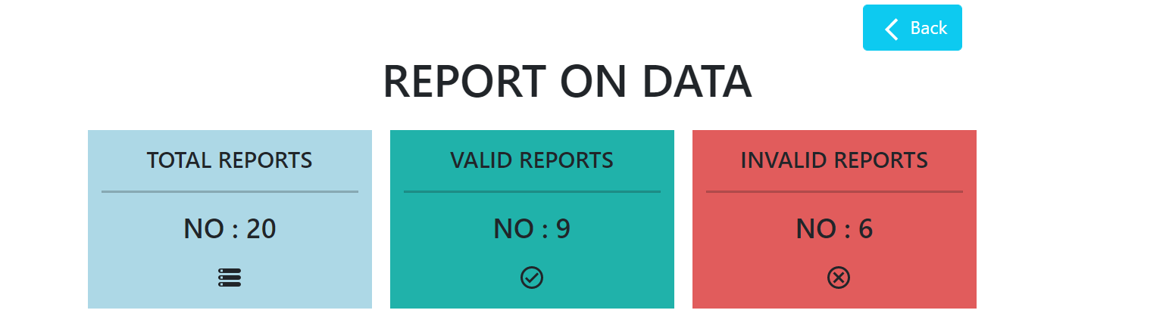

* **Map the valid data**
* Map the valid data and upload into MongoDB
* Map the errors in to report above

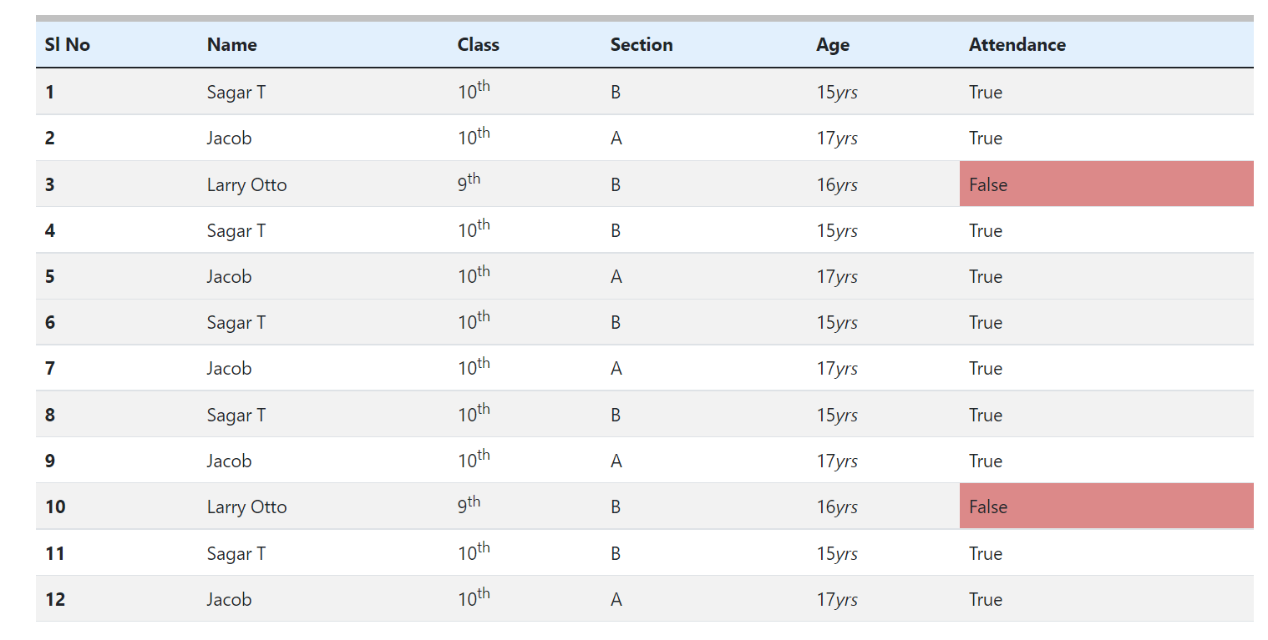

* **On next upload**
* On next upload of file check for duplicate value in database and upload file
* Map the duplicate values and errors on report on data
* Map the valid data into table

**Technology**

**Front End**

* React-Bootstrap
* React.js
* Axios
* Xlxs
* Yup

**Back End**

* Express.js
* Cros
* Mongoose
* Body-parse

**Date Base**

* Mongodb

**Tool**

* Postman
* vscode
* Git with github (version control)

**Workflow**

